Assignment 5: Random Undersampling

Shaun Pritchard

Florida Atlantic University

CAP 6778

October 29, 2021

M. Khoshgoftaar

**Assignment 5: Random Undersampling**

For this analysis, I will be using Weka to implement random under-sampling techniques using Define data set ratios of sub-sampled data. The evaluation will explore random undersampling on the Naïve Bayes and K-nearest Neighbors(5) learners.

**Part I: Preliminary classification**

Use the full data set to build models with each of these two (NaiveBayes and KNN(5)) classifiers and compare their results in terms of the false positive rate, false-negative rate, and AUC (area under the ROC curve). Use 10-fold cross-validation and no filter for random under-sampling for a baseline.

**Part II: Random Undersampling**

Here, I will apply random undersampling before building your classification models. Use the “SpreadSubsample” filter in Weka to create random undersampled datasets. The current dataset has a class imbalance of 77:23. I will undersample the original data to produce datasets with 50:50 and 65:35 class ratios.

Then use the random undersample datasets with the classifiers in Part 1 to create a total of four new models. Again, examine the effects of random undersampling in terms of FPR, FNR, and AUC, paying special attention to how these models compare with those built-in Part 1.

Additionally, include the filter settings used for each round of undersampling (include screenshots in the report). Use 10-fold cross-validation for each sampled dataset.

## **Preliminary Overview**

Using the Weka random under UnderSampling filter, I adjusted the distribution spread variable to define 50:50 and 65:35 as the ratio goals of this assignment. Whereas, The maximum class distribution spread. (0 = no maximum spread, 1 = uniform distribution, 10 = allow at most a 10:1 ratio between the classes for the full (77:23) ratio of ACL and nonACL classes. The initial variable of the distribution spread at 50:50:= 1 which created the subsets with 46 instances out of the 95 original instances. The distribution spread was calculated as 1.85 for 65:35. Taking 65 / 35 as a ratio, 64 instances were created. It is also recommended to verify the instance based on 65% of 95 original cases, which is approximately 61.75. A value of 1.7 seemed more appropriate which provided 62 instances, corresponding to a ratio of 65:35. For this reason, both (1.8 and 1.7) distribution values are applied to each learner for more accurate results. The second step I took was to divide these instances to check for the 50:50 ratio, whereas 50% of 95 was evaluated at approximately 47.5 instances. Using a uniform distribution value of 1, 46 instances were produced, which is about 47.5.

## **Part I**

For this analysis, no Random Undersampling(RUS) was applied to the dataset using the Naive Bayes and (5)K-nearest neighbor classifiers. Table 1-1 and chart 1-1 show that Naive Bayes outperforms the KNN learner in terms of Type II errors, but the KNN learner slightly outperforms the Naive Bayes under the ROC curve and RMSE.

Table 1-1

| **Evaluation for Assignment 5 - Part 1 -Random Undersampling** | | | | | | | | |
| --- | --- | --- | --- | --- | --- | --- | --- | --- |
| **Classifier / Learners** | **Type I** | **Type II** | **Type I Error rate %** | **Type II Error rate %** | **Misclassification Rate %** | **Correctly Classified %** | **ROC** | **RMSE** |
| NaiveBayes | 11 | 5 | 21.70% | 15.30% | 16.84% | 83% | 0.844 | 0.4115 |
| KNN (5) | 7 | 9 | 39.10% | 9.70% | 16.8 | 83% | 0.863 | 0.3573 |

Chart 1-1

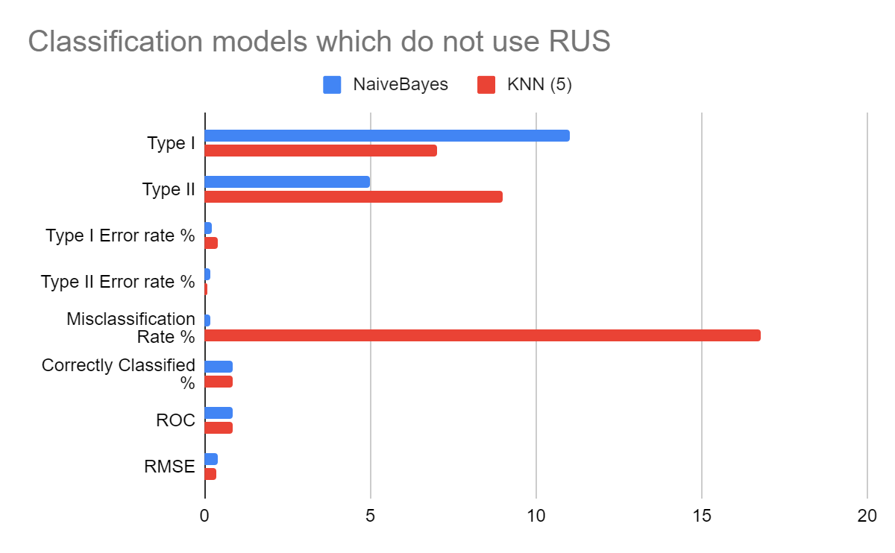

## **Part II**

This section evaluates the use of Random Undersampling(RUS) using the spreadSubSmaple filter with distribution weight ratios applied to 50:50 and 65:35 of the 77:23 based 95 ratio dataset. To obtain more precision in values to match the 65:35 ratio two initial values were used for the distribution weight value (1.7 and 1.8). The following table2-1 shows the order of cleaner with and without RUC with variation in distribution ratio according to best performing Area Under the ROC curve.KNN without RUC shows to have the best performance in comparison to all instances and also proves to have the lowest Type II error rate.

| **Evaluation for Assignment 5 - Random Undersampling** | | | | | | | | |
| --- | --- | --- | --- | --- | --- | --- | --- | --- |
| **Classifier / Learners** | **Type I** | **Type II** | **Type I Error rate %** | **Type II Error rate %** | **Misclassification Rate %** | **Correctly Classified %** | **ROC** | **RMSE** |
| KNN (5) | 7 | 9 | 39.10% | 9.70% | 16.80% | 83% | 0.863 | 0.3573 |
| NaiveBayes | 11 | 5 | 21.70% | 15.30% | 16.84% | 83% | 0.844 | 0.4115 |
| NaiveBayes + (US 65:35) =1.8 | 6 | 5 | 21.70% | 14.60% | 17.00% | 83.00% | 0.831 | 0.4146 |
| NaiveBayes + (US 65:35) =1.7 | 6 | 6 | 26.10% | 15.40% | 19.30% | 80.64% | 0.824 | 0.4399 |
| KNN (5) + (US 65:35) =1.8 | 19 | 2 | 8.70% | 46.30% | 33.00% | 67.10% | 0.807 | 0.4455 |
| NaiveBayes + (US 50:50) | 7 | 5 | 21.70% | 30.40% | 26.09% | 73.90% | 0.803 | 0.5108 |
| KNN (5) + (US 65:35) =1.7 | 18 | 2 | 8.70% | 46.20% | 32.20.% | 67.70% | 0.775 | 0.4567 |
| KNN (5) + (US 50:50) | 18 | 1 | 4.30% | 78.30% | 41.36% | 58.60% | 0.749 | 0.5122 |

The 50:50 ratio and 65:35 ratio utilizing RUC show that Naive Bayes is the superior solution, with distribution weights set to 1.8, 2nd best ROC value at 0.831, and 14.60% Type II error rate. We see that the 65:35 ratio outperforms the 50:50 ratio distribution for both Naive Bayes and KNN learners. Also, we see Naive Bayes with 65:35 distribution ratio outperforms KNN with 65:35 distribution ratio as displayed in chart 2-1.

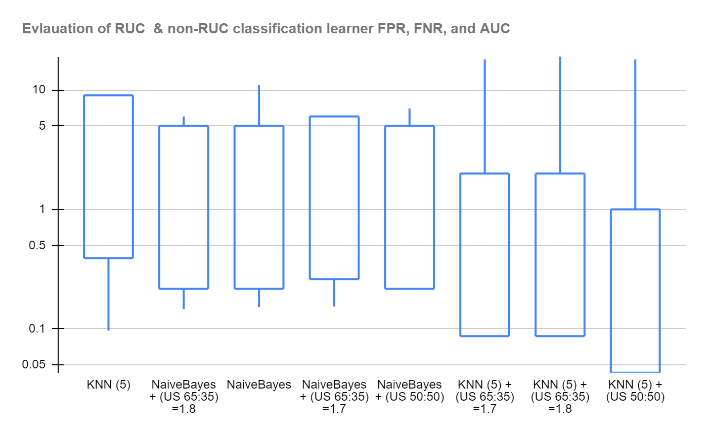

## **Filter Settings:**

Screenshots of Random undersampling(RUC) at first approximate distribution weight to match 65:35 ratio with value of 1.7 and 62 instances.

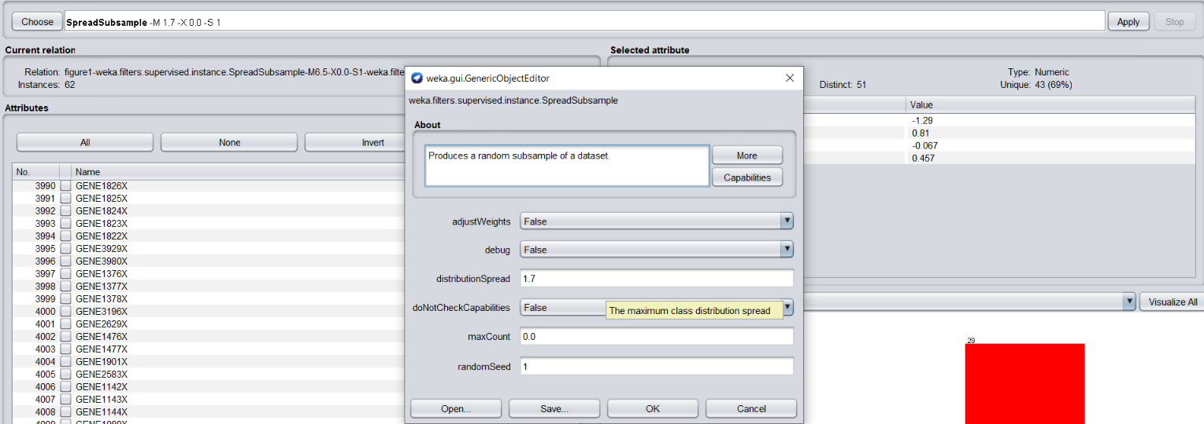

Screenshots of Random undersampling(RUC) at first approximate distribution weight to match 65:35 ratio with value of 1.8 and 64 instances.

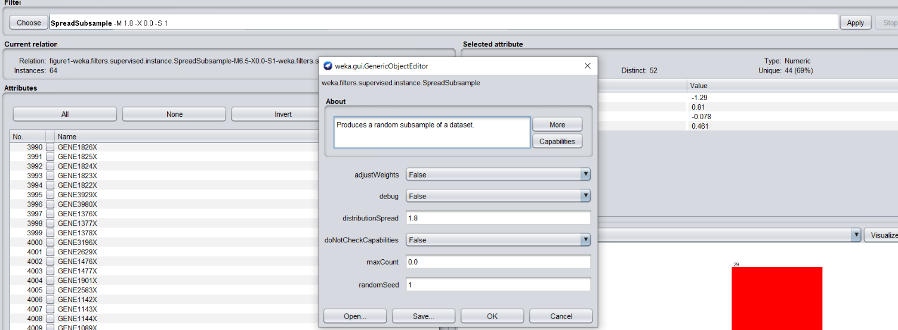

## **Appendices :**

This appendix contains the results of the data evaluation and inference from Weka using the assignment parameters.

1. Naive Bayes with no RUS
2. KNN (5) with no RUS
3. Naive Bayes with RUS 50:50 ratio
4. KNN (5) with RUS 50:50 ratio
5. Naive Bayes with RUS 35:35 ratio value set to 1.8
6. KNN (5)with RUS 35:35 ratio value set to 1.8
7. Naive Bayes with RUS 35:35 ratio value set to 1.7
8. KNN (5)with RUS 35:35 ratio value set to 1.7
9. Naive Bayes with no RUS

Time taken to build model: 0.1 seconds

=== Stratified cross-validation ===

=== Summary ===

Correctly Classified Instances 79 83.1579 %

Incorrectly Classified Instances 16 16.8421 %

Kappa statistic 0.5785

Mean absolute error 0.1715

Root mean squared error 0.4115

Relative absolute error 46.322 %

Root relative squared error 95.9589 %

Total Number of Instances 95

=== Detailed Accuracy By Class ===

TP Rate FP Rate Precision Recall F-Measure MCC ROC Area PRC Area Class

0.783 0.153 0.621 0.783 0.692 0.586 0.851 0.569 ACL

0.847 0.217 0.924 0.847 0.884 0.586 0.842 0.916 nonACL

Weighted Avg. 0.832 0.202 0.851 0.832 0.838 0.586 0.844 0.832

=== Confusion Matrix ===

a b <-- classified as

18 5 | a = ACL

11 61 | b = nonACL

1. KNN (5) with no RUS

Time taken to build model: 0 seconds

=== Stratified cross-validation ===

=== Summary ===

Correctly Classified Instances 79 83.1579 %

Incorrectly Classified Instances 16 16.8421 %

Kappa statistic 0.5271

Mean absolute error 0.2685

Root mean squared error 0.3573

Relative absolute error 72.4907 %

Root relative squared error 83.3082 %

Total Number of Instances 95

=== Detailed Accuracy By Class ===

TP Rate FP Rate Precision Recall F-Measure MCC ROC Area PRC Area Class

0.609 0.097 0.667 0.609 0.636 0.528 0.863 0.583 ACL

0.903 0.391 0.878 0.903 0.890 0.528 0.863 0.947 nonACL

Weighted Avg. 0.832 0.320 0.827 0.832 0.829 0.528 0.863 0.858

=== Confusion Matrix ===

a b <-- classified as

14 9 | a = ACL

7 65 | b = nonACL

1. Naive Bayes with RUS 50:50 ratio

Time taken to build model: 0.02 seconds

=== Stratified cross-validation ===

=== Summary ===

Correctly Classified Instances 34 73.913 %

Incorrectly Classified Instances 12 26.087 %

Kappa statistic 0.4783

Mean absolute error 0.2609

Root mean squared error 0.5108

Relative absolute error 52.0161 %

Root relative squared error 101.8244 %

Total Number of Instances 46

=== Detailed Accuracy By Class ===

TP Rate FP Rate Precision Recall F-Measure MCC ROC Area PRC Area Class

0.783 0.304 0.720 0.783 0.750 0.480 0.808 0.735 ACL

0.696 0.217 0.762 0.696 0.727 0.480 0.799 0.752 nonACL

Weighted Avg. 0.739 0.261 0.741 0.739 0.739 0.480 0.803 0.744

=== Confusion Matrix ===

a b <-- classified as

18 5 | a = ACL

7 16 | b = nonACL

1. KNN (5) with RUS 50:50 ratio

=== Classifier model (full training set) ===

IB1 instance-based classifier

using 5 nearest neighbour(s) for classification

Time taken to build model: 0 seconds

=== Stratified cross-validation ===

=== Summary ===

Correctly Classified Instances 27 58.6957 %

Incorrectly Classified Instances 19 41.3043 %

Kappa statistic 0.1739

Mean absolute error 0.4139

Root mean squared error 0.5122

Relative absolute error 82.5248 %

Root relative squared error 102.1219 %

Total Number of Instances 46

=== Detailed Accuracy By Class ===

TP Rate FP Rate Precision Recall F-Measure MCC ROC Area PRC Area Class

0.957 0.783 0.550 0.957 0.698 0.258 0.749 0.690 ACL

0.217 0.043 0.833 0.217 0.345 0.258 0.749 0.745 nonACL

Weighted Avg. 0.587 0.413 0.692 0.587 0.522 0.258 0.749 0.718

=== Confusion Matrix ===

a b <-- classified as

22 1 | a = ACL

18 5 | b = nonACL

1. Naive Bayes with RUS 35:35 ratio value set to 1.8

Time taken to build model: 0.02 seconds

=== Stratified cross-validation ===

=== Summary ===

Correctly Classified Instances 53 82.8125 %

Incorrectly Classified Instances 11 17.1875 %

Kappa statistic 0.6303

Mean absolute error 0.1719

Root mean squared error 0.4146

Relative absolute error 37.1792 %

Root relative squared error 86.2832 %

Total Number of Instances 64

=== Detailed Accuracy By Class ===

TP Rate FP Rate Precision Recall F-Measure MCC ROC Area PRC Area Class

0.783 0.146 0.750 0.783 0.766 0.631 0.845 0.696 ACL

0.854 0.217 0.875 0.854 0.864 0.631 0.824 0.851 nonACL

Weighted Avg. 0.828 0.192 0.830 0.828 0.829 0.631 0.831 0.795

=== Confusion Matrix ===

a b <-- classified as

18 5 | a = ACL

6 35 | b = nonACL

1. KNN (5)with RUS 35:35 ratio value set to 1.8

Time taken to build model: 0 seconds

=== Stratified cross-validation ===

=== Summary ===

Correctly Classified Instances 43 67.1875 %

Incorrectly Classified Instances 21 32.8125 %

Kappa statistic 0.3869

Mean absolute error 0.351

Root mean squared error 0.4455

Relative absolute error 75.9342 %

Root relative squared error 92.7086 %

Total Number of Instances 64

=== Detailed Accuracy By Class ===

TP Rate FP Rate Precision Recall F-Measure MCC ROC Area PRC Area Class

0.913 0.463 0.525 0.913 0.667 0.446 0.807 0.636 ACL

0.537 0.087 0.917 0.537 0.677 0.446 0.807 0.877 nonACL

Weighted Avg. 0.672 0.222 0.776 0.672 0.673 0.446 0.807 0.790

=== Confusion Matrix ===

a b <-- classified as

21 2 | a = ACL

19 22 | b = nonACL

1. Naive Bayes with RUS 35:35 ratio value set to 1.7

Time taken to build model: 0.02 seconds

=== Stratified cross-validation ===

=== Summary ===

Correctly Classified Instances 50 80.6452 %

Incorrectly Classified Instances 12 19.3548 %

Kappa statistic 0.5853

Mean absolute error 0.1935

Root mean squared error 0.4399

Relative absolute error 41.3121 %

Root relative squared error 90.9232 %

Total Number of Instances 62

=== Detailed Accuracy By Class ===

TP Rate FP Rate Precision Recall F-Measure MCC ROC Area PRC Area Class

0.739 0.154 0.739 0.739 0.739 0.585 0.852 0.701 ACL

0.846 0.261 0.846 0.846 0.846 0.585 0.808 0.827 nonACL

Weighted Avg. 0.806 0.221 0.806 0.806 0.806 0.585 0.824 0.780

=== Confusion Matrix ===

a b <-- classified as

17 6 | a = ACL

6 33 | b = nonACL

1. KNN (5)with RUS 35:35 ratio value set to 1.7

Time taken to build model: 0 seconds

=== Stratified cross-validation ===

=== Summary ===

Correctly Classified Instances 42 67.7419 %

Incorrectly Classified Instances 20 32.2581 %

Kappa statistic 0.3951

Mean absolute error 0.3559

Root mean squared error 0.4567

Relative absolute error 75.9599 %

Root relative squared error 94.39 %

Total Number of Instances 62

=== Detailed Accuracy By Class ===

TP Rate FP Rate Precision Recall F-Measure MCC ROC Area PRC Area Class

0.913 0.462 0.538 0.913 0.677 0.452 0.775 0.620 ACL

0.538 0.087 0.913 0.538 0.677 0.452 0.775 0.864 nonACL

Weighted Avg. 0.677 0.226 0.774 0.677 0.677 0.452 0.775 0.773

=== Confusion Matrix ===

a b <-- classified as

21 2 | a = ACL

18 21 | b = nonACL